VLSI Lab 6 – Charge Pump
  - Matthew Murray – 873525242

3-Stage charge pump
Due to unrealistic layout sizes, the capacitors and resistors are replaced with exports with the assumption they will be off-chip.

Schematic
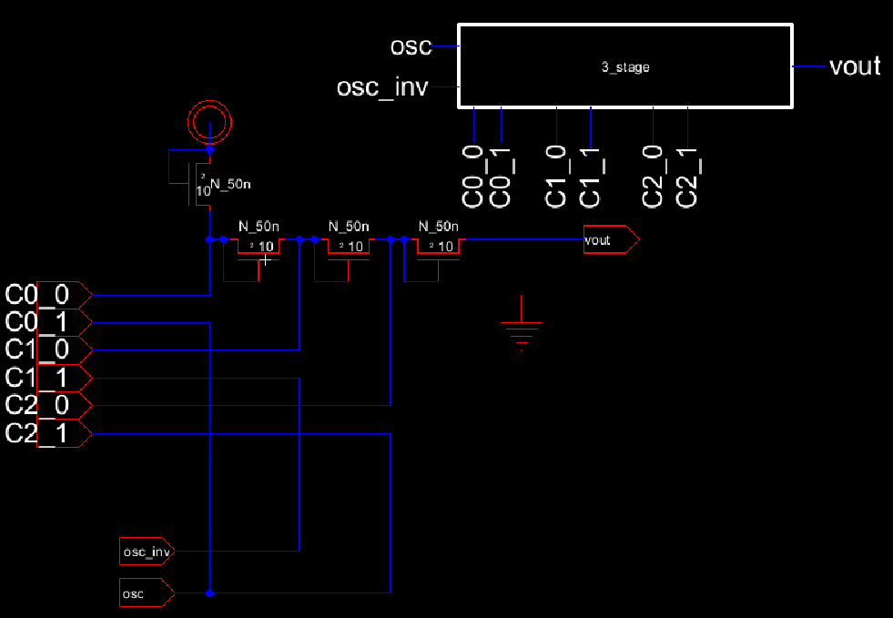

Layout
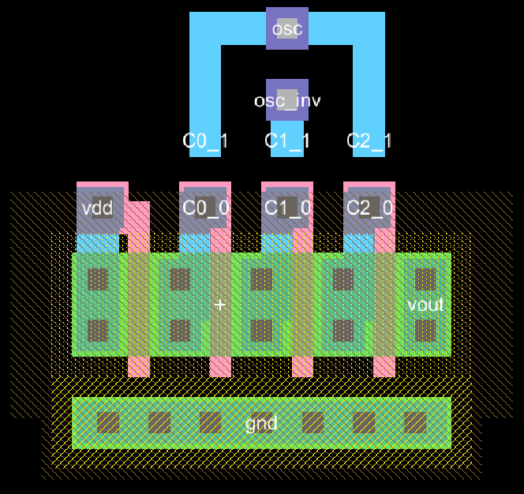
The capacitor pins are floating wires to serve as connection points in the final design (and pass NCC)

Simulation
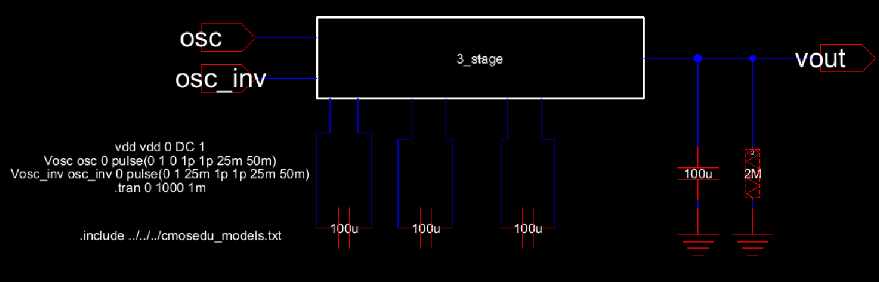
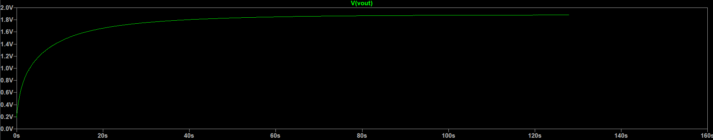

Ring Oscillator
The ring oscillator also assumes capacitors are off-chip due to unrealistic sizes. The capacitors are used to reduce the frequency of the oscillator for more stable simulation.

Schematic
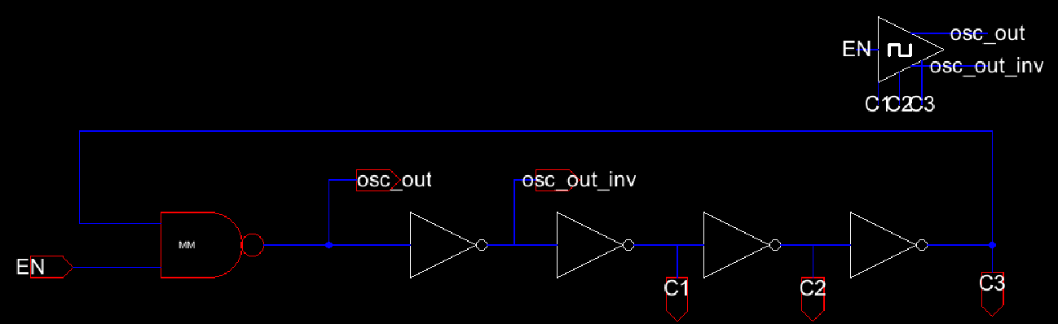

Layout
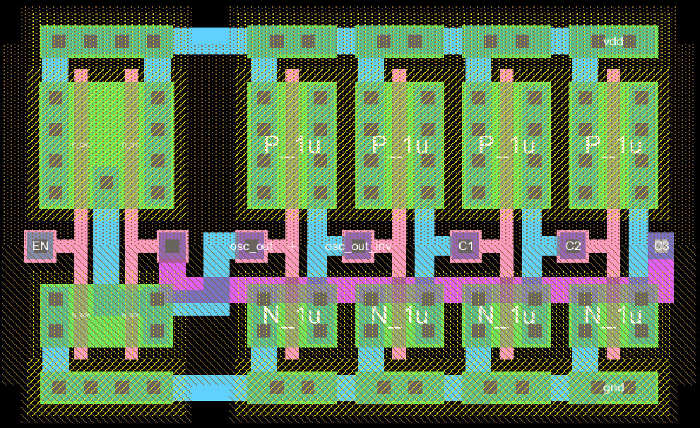

Simulation
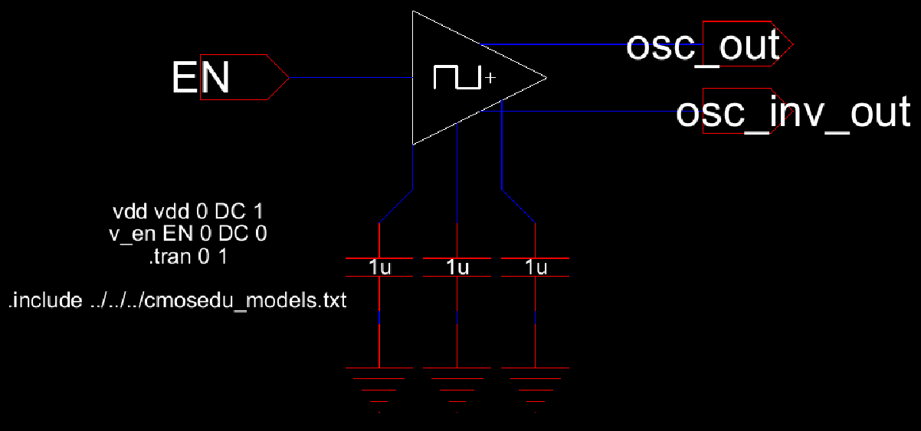
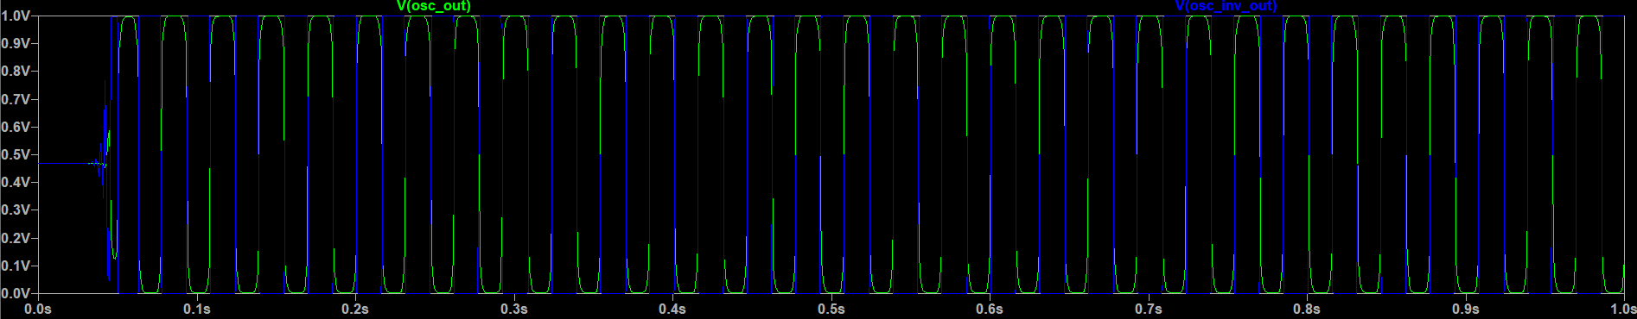

Regulator Circuit
I found a Schmitt trigger circuit is good for regulation due to its built in hysteresis. You tune the high/low threshold voltages to set the ripple of the output as needed. In this case I set the voltages as close as realistically possible for less output ripple. As with the other circuits, the input resistors are too large to reasonably fit on a chip, and are assumed to be off-chip – which has the added bonus of allowing the “user” to set the output voltage just by re-soldering the resistors.

Schematic
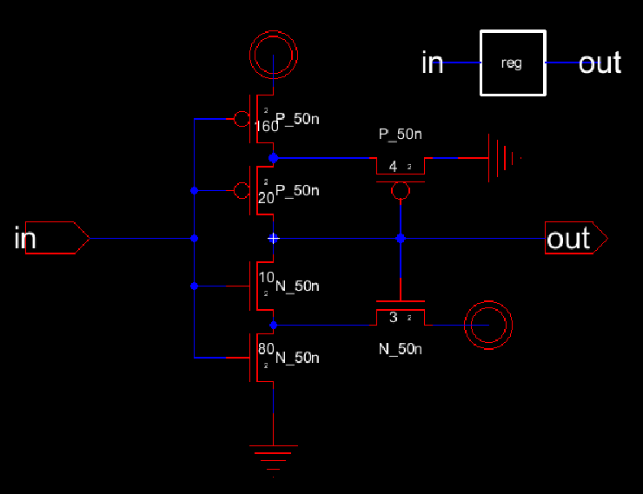

Layout
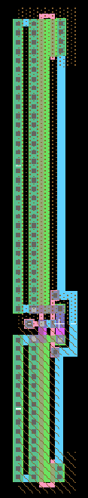
The layout is very long since the transistors are tuned for tight threshold voltages.

Full Charge Pump

Schematic
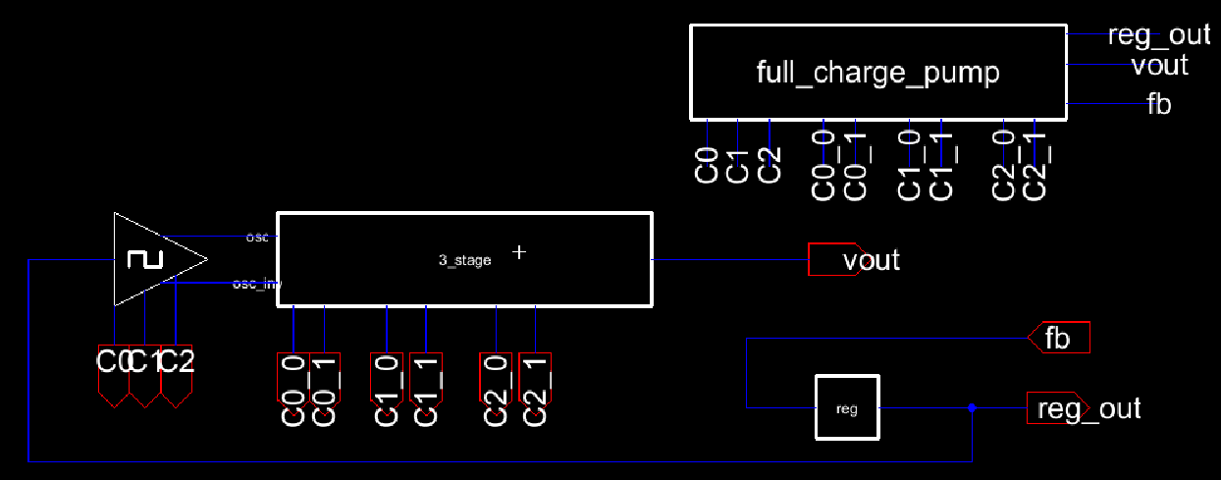

Layout
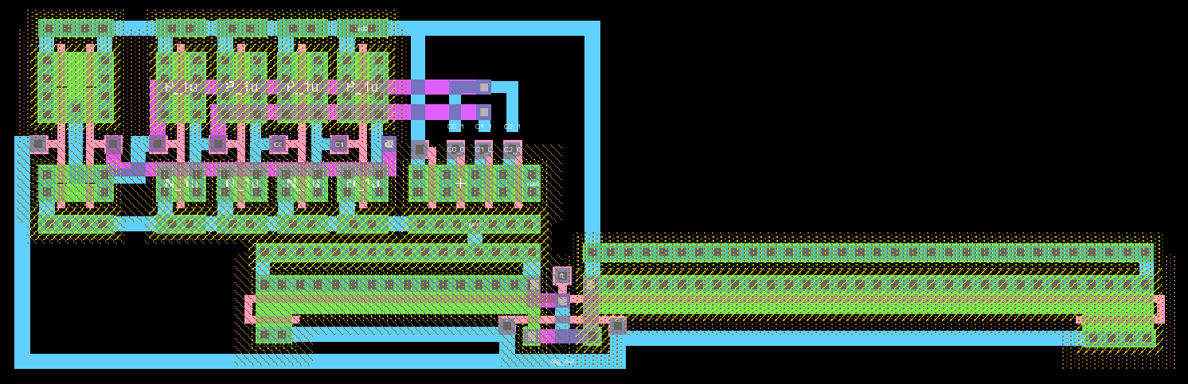

Simulation
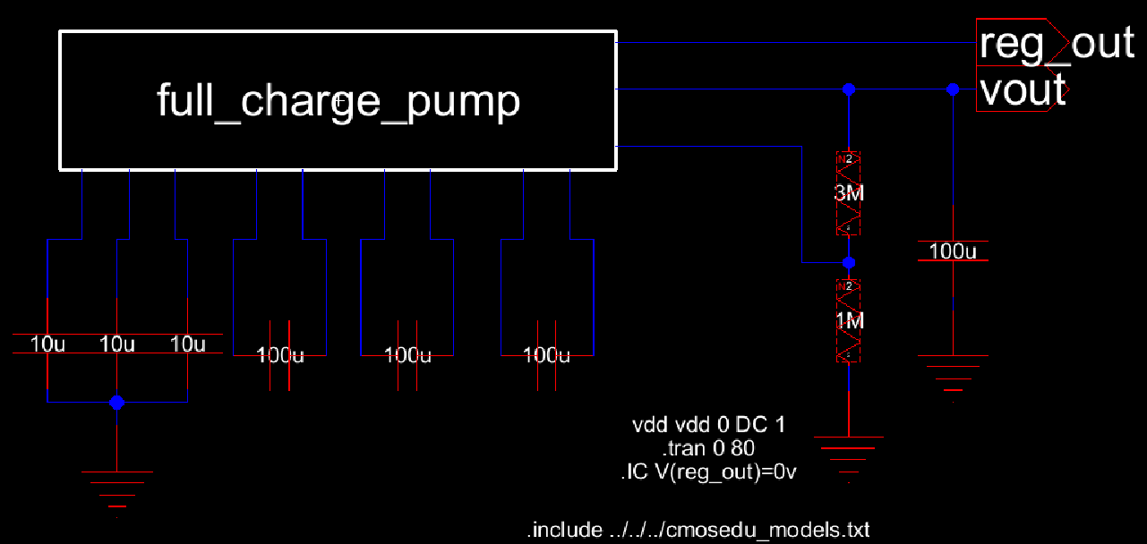
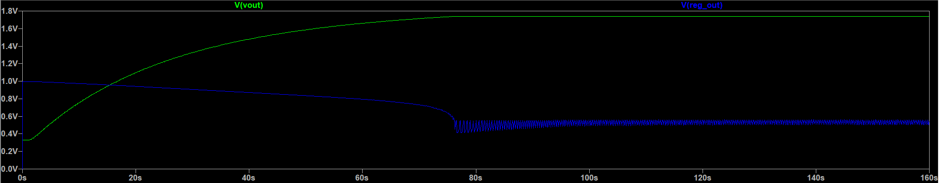
The charge pump slowly builds up to roughly 2V before the regulator starts dropping and holding the output voltage there.
The regulator can be tuned for more hysteresis though to eliminate its output voltage hovering around 0.5V like the following sim:
